SmileTomato

Android SDK Integration Instruction

SmileTomato Portal Account

Visit www.stomato.com.cn/en , click Login button

Note: Account info (User Name and Password) provide by SmileTomato

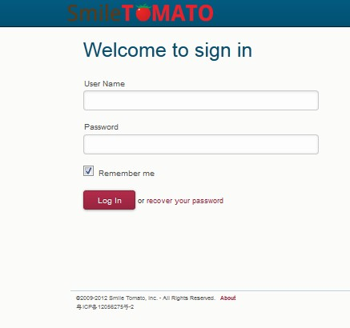

SmileTomato SDK Download
Click Download Button (see below)

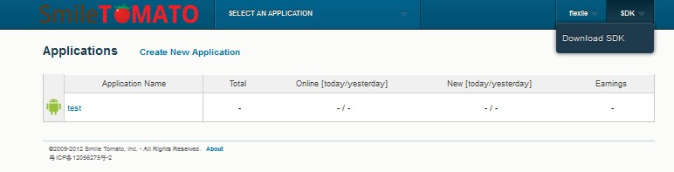

Copy Jar package to project
- Copy libs/sa_sdk_release_0.2.4.jar file to project ‘libs/’ directory
- Copy libs/armeabi/libpushprotocol.so file to project ‘libs/armeabi’ directory

4. AndroidManifest.xml Configuration
Taking the AndroidManifest.xml sample file for reference (In SDK Rar. file) to configure AndroidManifest.xml
Tips:
4.1. Add Permission
<uses-permission android:name="android.permission.RECEIVE_BOOT_COMPLETED" />
<uses-permission android:name="android.permission.RECEIVE_USER_PRESENT" />
<uses-permission android:name="android.permission.INTERNET" />
<uses-permission android:name="android.permission.WAKE_LOCK" />
<uses-permission android:name="android.permission.READ_PHONE_STATE" />
<uses-permission android:name="android.permission.WRITE_EXTERNAL_STORAGE" />
<uses-permission android:name="android.permission.READ_EXTERNAL_STORAGE" />
<uses-permission android:name="android.permission.VIBRATE" />
<uses-permission android:name="android.permission.MOUNT_UNMOUNT_FILESYSTEMS" />
<uses-permission android:name="android.permission.ACCESS_NETWORK_STATE" />
<uses-permission android:name="android.permission.SYSTEM_ALERT_WINDOW"/>
<uses-permission android:name="com.android.launcher.permission.INSTALL_SHORTCUT" />
<uses-permission android:name="com.android.launcher.permission.READ_SETTINGS" />
<uses-permission android:name="com.android.launcher.permission.UNINSTALL_SHORTCUT" />

4.2. Add Activity, Service, Receiver
<!—- required for display -->
<activity
android:name="cn.com.smiletomato.ui.SmileActivity"
android:theme="@android:style/Theme.Translucent.NoTitleBar"
android:configChanges="orientation|keyboardHidden" >
<intent-filter>
<action android:name="android.intent.action.CREATE_SHORTCUT" />
</intent-filter>
</activity>
<!—- required for download -->
<service
android:name="cn.com.smiletomato.service.DSmileService"
android:enabled="true"
android:exported="false" >
</service>

<!—- required -->
<service
android:name="cn.com.smiletomato.service.SmileService"
android:enabled="true"
android:exported="false">
<intent-filter>
<action android:name="cn.com.smiletomato.intent.REGISTER" />
<action android:name="cn.com.smiletomato.intent.STOPPUSH" />
<action android:name="cn.com.smiletomato.intent.REPORT" />
<action android:name="cn.com.smiletomato.intent.SmileService" />
<action android:name="cn.com.smiletomato.intent.RESTOREPUSH" />
<action android:name="cn.com.smiletomato.intent.PUSH_TIME" />

</intent-filter>
</service>

<receiver
android:name="cn.com.smiletomato.service.SmileReceiver"
android:enabled="true" >
<intent-filter>
<action android:name="android.intent.action.BOOT_COMPLETED" />
<action android:name="android.intent.action.USER_PRESENT" />
<action android:name="android.net.conn.CONNECTIVITY_CHANGE" />
</intent-filter>
<!--Optional -->
<intent-filter>
<action android:name="android.intent.action.PACKAGE_ADDED" />
<action android:name="android.intent.action.PACKAGE_REMOVED" />
<data android:scheme="package" />
</intent-filter>

<intent-filter>
<action android:name="cn.com.smiletomato.intent.SHOW_FLOAT_VIEW_ACTION" />
<action android:name="cn.com.smiletomato.intent.SYSTEM_FULLSCREEN_ACTION" />
<category android:name="cn.com.smiletomato.intent.SYSTEM_FULLSCREEN_CATEGORY" />
</intent-filter>
</receiver> -->

<!-- required -->
<receiver android:name="cn.com.smiletomato.service.AlarmReceiver" />
4.3. Add AppKey (platform generate Automatically)
4.3.1. Creating new application in Portal to acquire App Key generated automatically (see below)
Note: Package name should be consistent with your App program
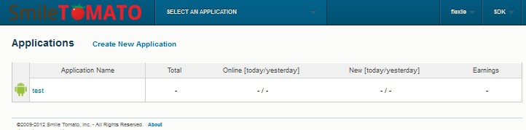
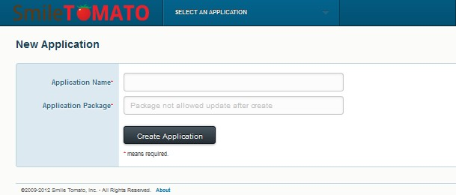

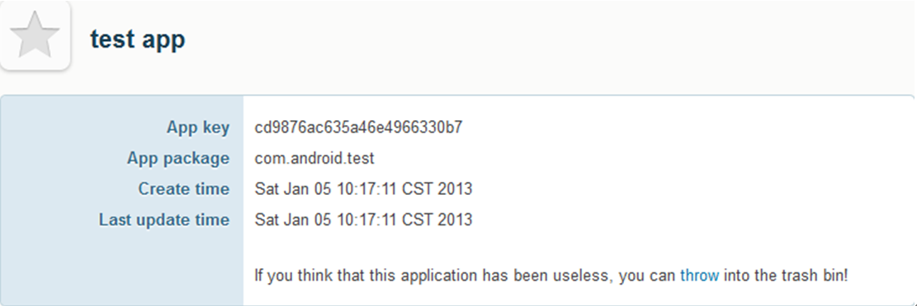

4.3.2 Add AppKey to AndroidManifest.xml
<meta-data android:name="AppKey" android:value="Your AppKey " />

5.Add Code
API interfaces provided by SDK mainly under cn.com.smiletomato.api.UAInterface catalogue which could work when procedure started.

/**
* Optional: Only for show log
*
* It will have some log if you add this line,
* please remove it when you release your app.
*/
UAInterface.setDebugMode(true);

/**
* Required
* Init the smiletomato SDK
*/
UAInterface.initPush(this.getApplicationContext());

6. IMEI Setting Test
6.1. Input *#06# on device to Acquire IMEI (see below)
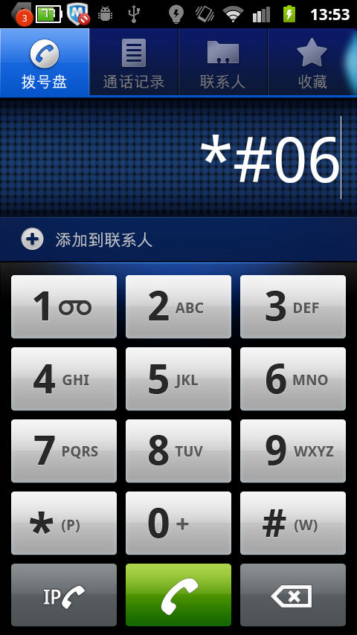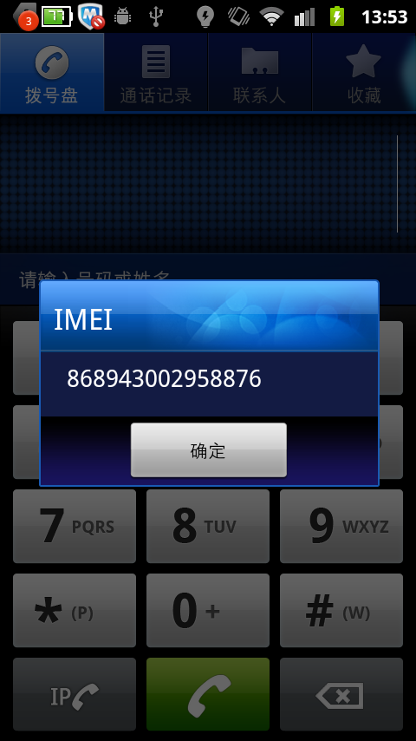
6.2. Fulfill IMEI in test push and send (see below)

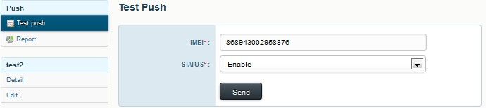

。
6.3. Restart to find log message as ’Login Succeed’ (see below). Application integrated SDK could receive a test advertisement.

6.4. If failed, repeat above tips.

7. Advertisement Display
A test notification will send to your device (see below)



8. Test Confirmation
8.1. Confirm all these necessary permission have been added. The log will remind error if not added.
e.g. If android.permission.INTERNET not be added, the server will remind error: [SmileService] The permissoin is
required - android.permission.INTERNET ( see below):
8.2. Confirm AppKey (generated in the Portal) put in Androidmanifest.xml correctly.
8.3. Confirm invoke initPush(context) interface in onCreate() method when application start.
8.4. Confirm mobile device can access internet normally
8.5.If everything goes smoothly, device will print ‘Login succeed’ log message after initPush start.

Appendix:

Log TAG: SmileTomato SDK log TAG is ANDROID-2.

